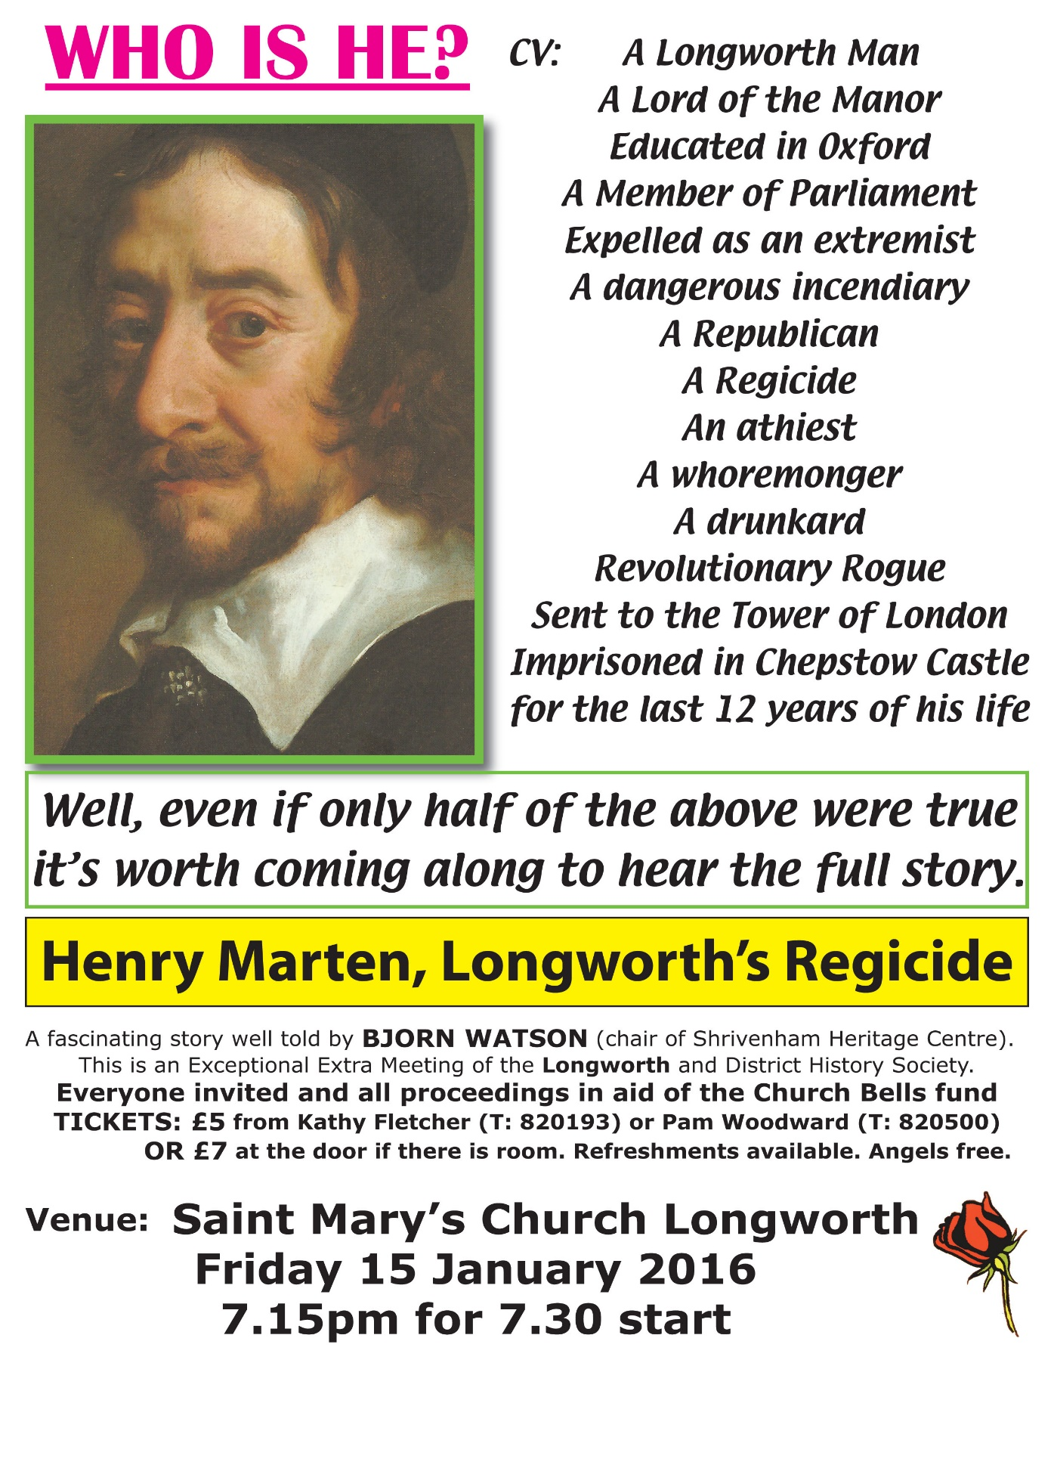

**St.Mary’s Church Longworth Bell Restoration Appeal   
aims to raise £120,000 to restore the bells - they have not been heard since 1922.   
Tickets sales on 01865820193 or 820500 Thank you for your support.**